What is Big Data?
- Definition by characteristics: Dough Laney defines Big Data on the basis of 3Vs, viz., Volume, Variety, and Velocity (2 more V’s have been added i.e. Veracity and Value)
- Volume: As per IBM, 2.5 Exabyte of data is generated every day. By 2020, the total data will add up to 40,000 Exabyte! A single storage server cannot store such vast amounts of data. Hence, a need for network of storage devices called SANs (i.e. Storage Area Networks) arises.
- Velocity: Speed at which data is generated and the promptness at which it needs to be processed. Some researchers believe that 90% of the world’s data was generated in the last two years alone. Big Data poses a huge challenge for social networking sites. For example, Facebook needs to store petabytes of data generated by its 1.65 billion active monthly users. Such streaming data needs to be stored and queries need to be processed in real-time.
- Variety: Traditional data types only include structured data, which perfectly fits in the case of an RDBMS. The digital world has opened up its doors to unstructured data making RDBMS no longer viable. Almost 80% of the data today is unstructured and cannot be classified into tables. With the aid of Big Data technologies, it is now possible to consolidate this data and make sense of it.
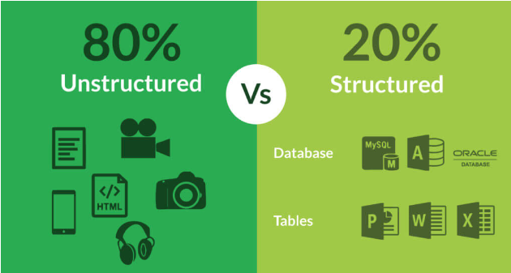
- Veracity: means the biases, noises and abnormality in data. In other words, how dependable, reliable or certain the data is. Uncertainty may exist due to incompleteness and inconsistency. With the amount of data surging, the accuracy of the data surely takes a toll. This then leads to the big question, “Can I trust this data and the insights it provides? A lot of “dirty data” may exist in the system.
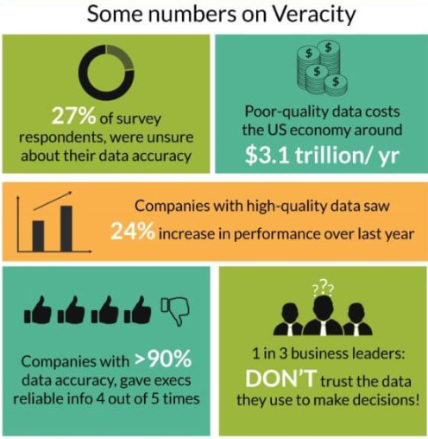
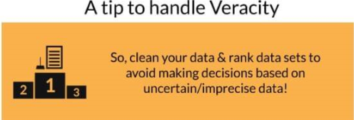
- Value: The main aim of delving into an ocean of data is to bring some value out of it.
This requires financial and hardware investments in infrastructure & resources to handle and analyze Big Data. As a result, it’s crucial to do a cost-benefit analysis before investing in Big Data projects.

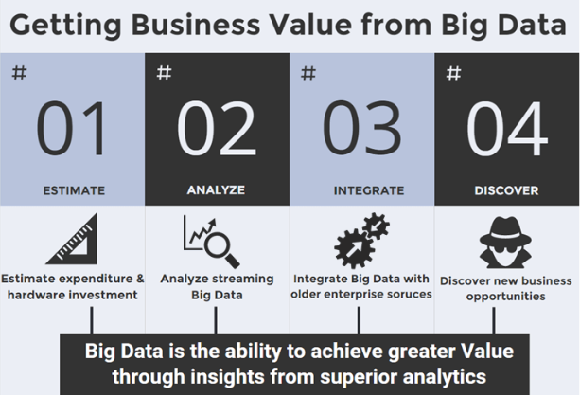

- Definition by sources:
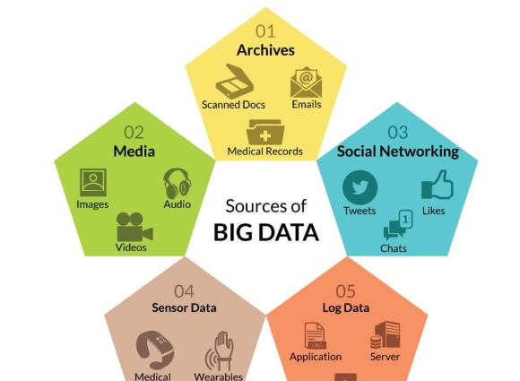

- Definition by importance:
- Reduce costs: data storage is cheap. Cloud storage platform (like Azure and Amazon s3) reduces costs of analytics by reducing capex and opex.
- Improves products and services by providing key insights of what customer wants and offer new products. Example, Netflix created house of Cards purely based on insights.
- Outdo competition: personalizing products based on insights.
- Better decision making: by basing decisions on data.


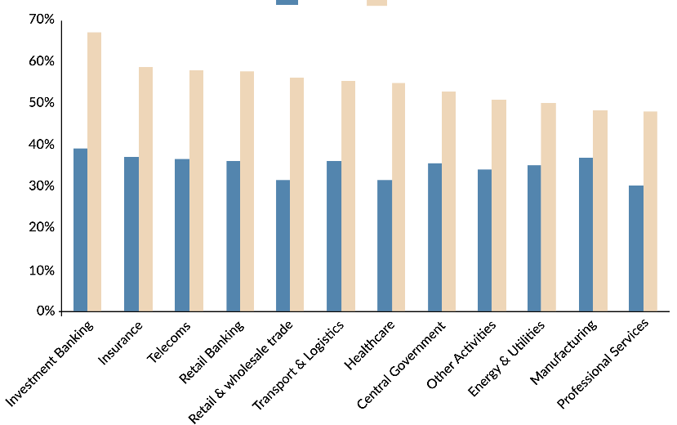

Communications and Media
The communications and media industry is using Big Data technologies for collecting, analyzing, and utilizing consumer insights and preferences. It is also leveraging mobile and social media data to comprehend patterns in media usage. It analyzes customer and behavioral data to create and recommend content for different target audiences.
Telecom giants such as Vodafone and AT&T use Big Data analytics for customer experience management and network capacity planning and optimization. The data collected in the cell towers then helps them in identifying the weak spots in their coverage area.

Sports
Data from wearable devices (i.e. GPS trackers and fitness trackers) provides stats on each player such as their speed, heart rate, and acceleration. Coaches can use this data to select the best players and make smarter decisions on the field or court.
Houston Rockets measures player efficiency: Houston Rockets uses Big Data analytics to measure player efficiency and defensive effectiveness. A player’s value is measured by metrics such as player’s efficiency rating, contribution in the wins and skill, and fitness over other players.

IBM SlamTracker predicts players’ performance
IBM along with the United States Tennis Association started the IBM SlamTracker. This offers real-time statistics to tennis fans across six digital platforms, including the U.S. Open’s official smartphone app and website. They use 41 million data points to predict the aspects of a player’s game determining his or her performance in a match.

How many nodes does e-comm/media giants have:
- Yahoo: Today, Yahoo has over 40,000 nodes spread across 4 data centres running Hadoop with the processing power of 100,000 CPUs. Its biggest cluster has 4500 nodes, with each node having octa-core processors with 4 TB storage capacity & 16 GB RAM.
- Twitter: uses Apache Hadoop to store and process tweets, log files, and other forms of data that are generated every day
- The New York Times: uses Amazon S3 for storing the articles and Amazon EC2 to run Hadoop on large virtual clusters.
- LinkedIn: It currently has 2 major clusters, one with 1100 nodes and the other with 300 nodes. Each of these nodes has 8 cores and 12 TB of storage capacity.

3 Ways in which analytics can enhance sales:
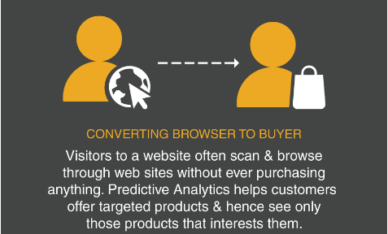
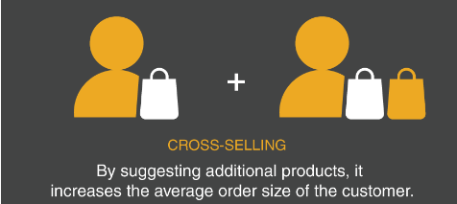
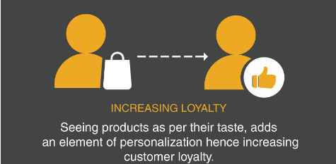
Techniques of predictive analytics
- Recommendation systems: study behaviour patterns to know what one can choose from a collection of things which he has never experienced. Example, content based filtering (recommend based on customer’s past buying history), collaborative filtering (recommend products based on preferences of other customers for a set of products), user based collaborative filtering (relationship based on user preferences) and item based collaborative filtering (relationship between items).
- Sentiment Analysis: known as opinion mining i.e. gathering the sentiments to derive on a users’ opinion.
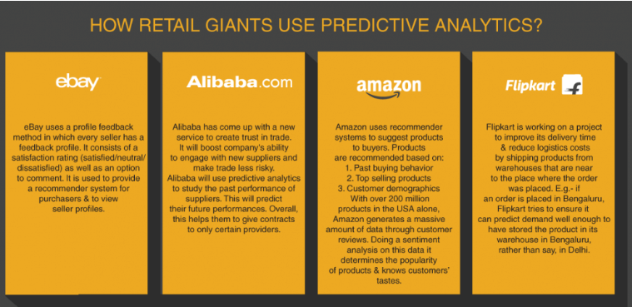

Big Data: Build Versus Buy
Companies can save 21% in Costs and Time Using Preconfigured Big Data Appliances (purpose-built infrastructure solutions such as Oracle's Big Data Appliance) than build data infrastructures from scratch.

Three Common Assumptions of Hadoop Big Data:
- Big data is not mission-critical. The amount and diversity of data; the number of points of internal and external integration; the wide variety and large quantity of users; and the expertise to ensure the analytic models and results can be trusted suggests that enterprises may want to consider a similar approach to what IT has used to deliver mission-critical solutions for the business in the past.
- Hadoop is free.
First, the expertise required to implement and use Hadoop is expensive. Big data will become a platform that will support many projects of discovery and analytics applications—it requires an enterprise lifecycle viewpoint and requisite infrastructure.
Second, any enterprise cannot only depend on Hadoop for big data solutions. Hadoop sits somewhere near the middle of an enterprise's big data solution set, connecting to Hadoop for data ingest and analytics visualization purposes may require significant administrative effort.
- Inexpensive infrastructure myth. Big data ROI factors involves choosing the right infrastructure. An enterprise-class big data infrastructure requires a robust and reliable architecture.
Identification, evaluation, and integration of a complete technology stack carries many hidden costs and human effort.

Build vs buy monetary investments
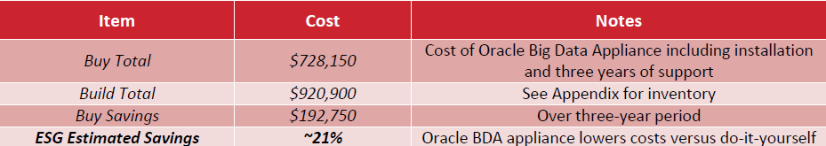
Build infra
structure cost

